AdvDevops-9

**Name- Maniya Motiramani**

**Class- D15b/38**

Create an Amazon Linux EC2 Instance in AWS.

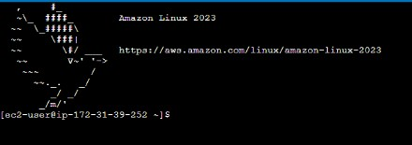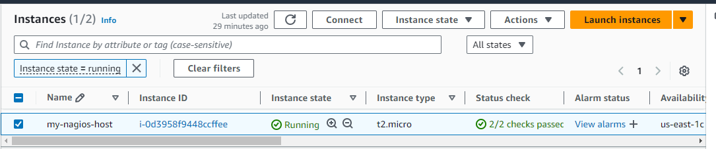

Update the package indices and install the following packages using yum sudo yum update

sudo yum install httpd php

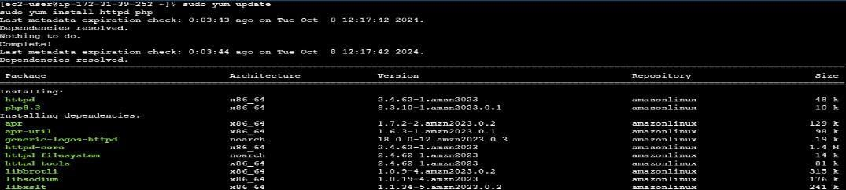

sudo yum install gcc glibc glibc-common sudo yum install gd gd-devel

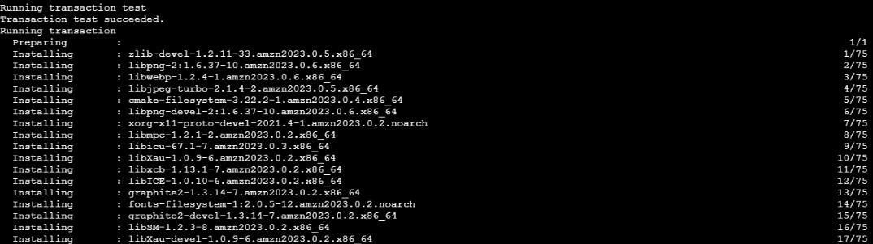

Create a new nagios user with password: sudo adduser -m nagios

sudo passwd nagios

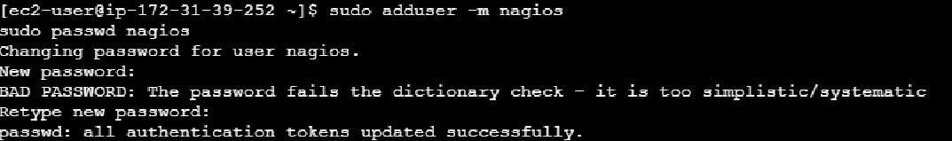

Create a new user group sudo groupadd nagcmd

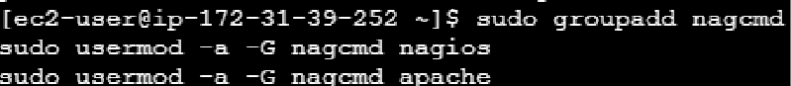sudo usermod -a -G nagcmd nagios sudo usermod -a -G nagcmd apache

Use wget to downloads the source zip files.

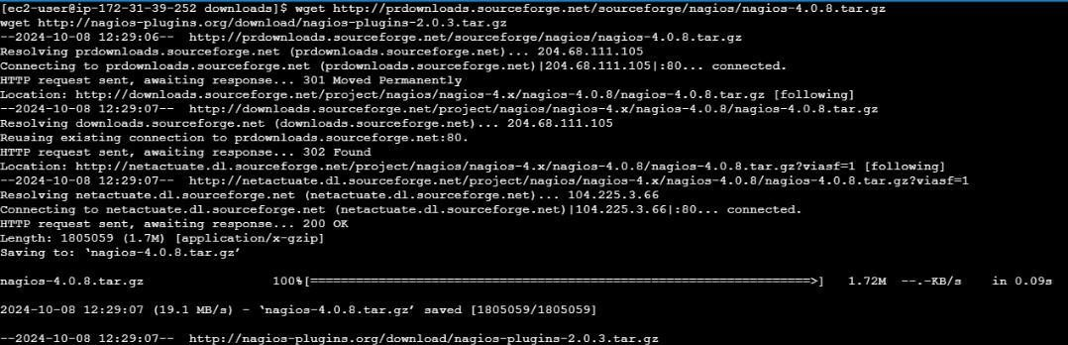

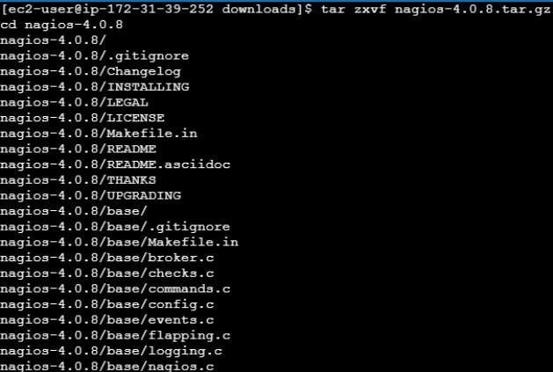

Run the configuration script with the same group name you previously created.

./configure --with-command-group=nagcmd

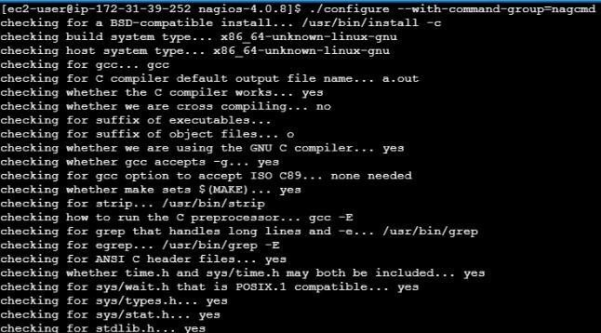

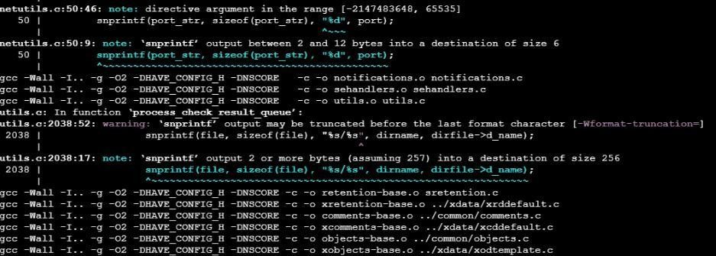

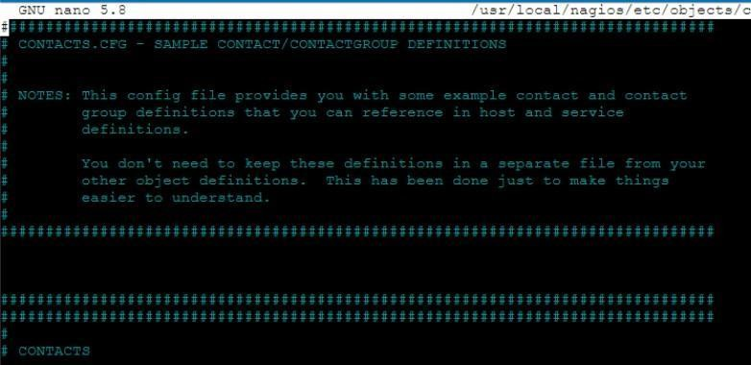Edit the config file and change the email address. sudo nano /usr/local/nagios/etc/objects/contacts.cfg

Configure the web interface. sudo make install-webcon

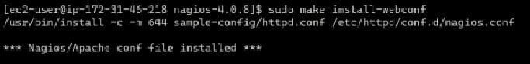

Create a nagiosadmin account for nagios login along with password. You’ll have to specify the password twice.

sudo htpasswd -c /usr/local/nagios/etc/htpasswd.users nagiosadmin

Go back to the downloads folder and unzip the plugins zip file. cd ~/downloads

tar zxvf nagios-plugins-2.0.3.tar.gz

Start Nagios

sudo service nagios start

